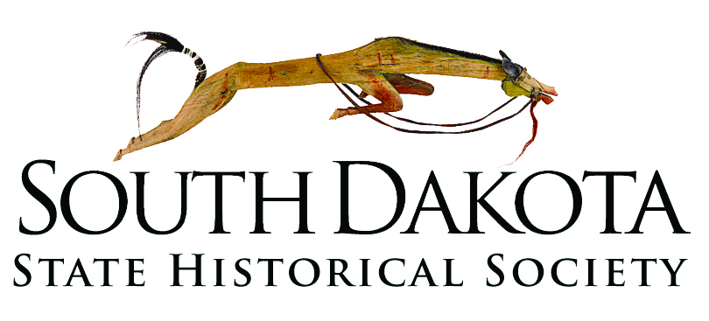

APPLICATION FOR A PERMIT UNDER
THE ARCHAEOLOGICAL EXPLORATION ACT (SDCL 1-20)
AND THE CEMETERIES AND BURIAL RECORDS ACT (SDCL 34-27)

ARCHAEOLOGICAL RESEARCH CENTER
PO Box 1257

Rapid City, SD 57709-1257
Phone: 1-605-394-1936 Fax: 1-605-394-1941
Email: archaeology@state.sd.us

Instructions: complete two copies of this application form and attachments and return to the Archaeological Research Center and to the office of the land managing agency involved. All information requested must be completed before the application will be considered. Use separate sheets of paper if more space is needed to complete a section.

1. Name of Institution 2. Address: (include zip code)
Address
Address
City, State, ZIP
Phone

2. Type of permit requested: (check appropriate box)

a. Surveys and limited testing/limited collections of lands identified in No. 3.

b. Excavation, collection and intensive study of specific sites described below in No. 3.

3. Location and managing agency for which a permit is requested:

a. Description: provide a legal description of the property for which the permit is requested

b. Attach a copy of a map, sketch, or plan showing specific sites or areas for which permit is desired.

4. Nature and extent of the work proposed, including how and why it is proposed to be conducted:

5. Name, address and institutional affiliation, if any, of persons in "a" and "b" below:

a. Individual(s) proposed to be responsible for conducting the work (i.e., in direct charge of field work): Include evidence of qualifications (résumés) in accordance with ARSD 24:52:08:02 and/or ARSD 24:52:09:02.

b. Individual(s) proposed to be responsible for carrying out the terms and conditions of the permit (i.e., in general charge):

6. Proposed date field work will begin: 7. Proposed time of performance:

8. University, museum or other scientific or educational institution in which the applicant proposes to store all collections and copies of records, data, photographs and other documents derived from the proposed work: (The application must include a written certification, signed by an authorized official of the institution, of willingness to assume curatorial responsibility, and to safeguard and preserve these materials as property of the state of South Dakota.)

9. Proposed outlet for public written dissemination of the results:

10. Evidence of the applicant's ability to initiate, conduct and complete the proposed work, including evidence of logistical support and laboratory facilities:

11. Signature of individual in general charge: 12. Date of application:

