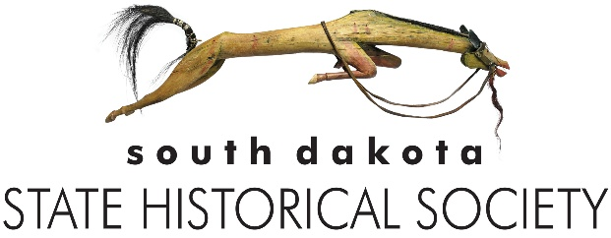
South Dakota State Archives
900 Governors Dr.
Pierre, SD 57501
605-773-3804 | Fax: 605-773-6041
StateArchives@state.sd.us
https://history.sd.gov/archives

Government Records Transfer Form
Records transferred to the State Archives of the South Dakota State Historical Society become property of the South Dakota State Historical Society and cannot be withdrawn from the Archives. It is understood that the purpose and intention of this transfer is to grant all property rights, title, and interest possessed in these materials to the Society, including the right to reproduce and publish. The State Archives may use its discretion to dispose of material inappropriate for the collection, unless otherwise specified by the transferring agency. Records are available for use in the State Archives Research Room.

Contact Information:
State Department/County/Municipality:

Division/Office:

Mailing Address:

Name and Title of Person Transferring Records:

Telephone:

Email:

Records Transferred:
Box No. | Records Series No. | Series Title and Description | Inclusive Dates

Signature Date
Retain a copy of this form for your records.

Archives Use Only:
Year: Entry #: Cu Ft: MB/GB: Staff:

