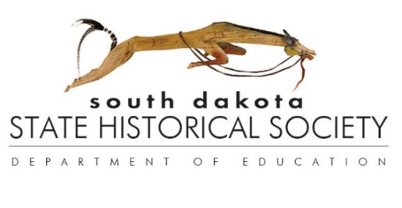
SOUTH DAKOTA STATE HISTORICAL SOCIETY
STATE ARCHIVES
900 GOVERNORS DRIVE
PIERRE, SD 57501-2217
(605) 773-3804
http://history.sd.gov/archives

GOVERNMENT RECORDS TRANSFER FORM

Records transferred to the State Archives of the South Dakota State Historical Society become property of the South Dakota State Historical Society and cannot be withdrawn from the Archives. It is understood that the purpose and intention of this transfer is to grant all property rights, title, and interest possessed in these materials to the Society, including the right to reproduce and publish. The State Archives may use its discretion to dispose of material inappropriate for the collection, unless otherwise specified by the transferring agency. Records are available for use in the State Archives Research Room.

FROM: ☐ State Agency ☐ County/Local Government
State Agency/County/Local Office: |  | Archives Use Only:  Year: __________  Entry #: _________  Cu. Ft: __________  MB/GB: _________  Staff: ___________
Division:

Mailing Address:

Telephone: | Email:
Name and Title of Person Transferring Records:

RECORDS TRANSFERRED
Box No. | Records Series No. | Series Title and Description | Inclusive Dates

__________________________________________________ __________________________
Signature Date

